WORKSHEET 2.4

Student Name: Ravi Shankar Singh UID: 21BCS11619

Branch: CSE Section/Group: 808-B

Semester: 4th Date of Performance:

Subject Name: Programming in Python Lab Subject Code: 21CSP-259

**Aim:**

**Program to demonstrate Program to demonstrate creation, accessing of tuples and apply different kinds of operations on them.**

1. **Write a Python program to replace last value of tuples in a list.**

**Source Code:**

my_list = [(1, 2, 3), (4, 5, 6), (7, 8, 9)]

for i in range(len(my_list)):

my_list[i] = my_list[i][0], my_list[i][1], 0

print(my_list)

**OUTPUT:**

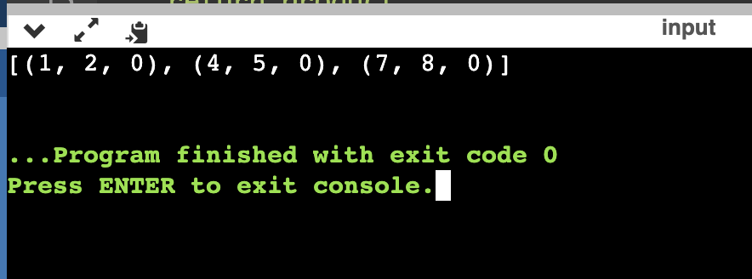

1. **Write a Python program to remove an empty tuple(s) from a list of tuples.**

**Source Code:**

L = [(), (), ('',), ('a', 'b'), ('a', 'b', 'c'), ('d')]

L = [t for t in L if t]

print(L)

# **OUTPUT:**

# 

1. **Write a Python program to calculate the product, multiplying all the numbers of a given tuple.**

**Source Code:**

def mutiple_tuple(nums):

temp = list(nums)

product = 1

for x in temp:

product *= x

return product

nums = (4, 3, 2, 2, -1, 18)

print ("Original Tuple: ")

print(nums)

print("Product - multiplying all the numbers of the said tuple:",mutiple_tuple(nums))

nums = (2, 4, 8, 8, 3, 2, 9)

print ("\nOriginal Tuple: ")

print(nums)

print("Product - multiplying all the numbers of the said tuple:",mutiple_tuple(nums))

**OUTPUT:**

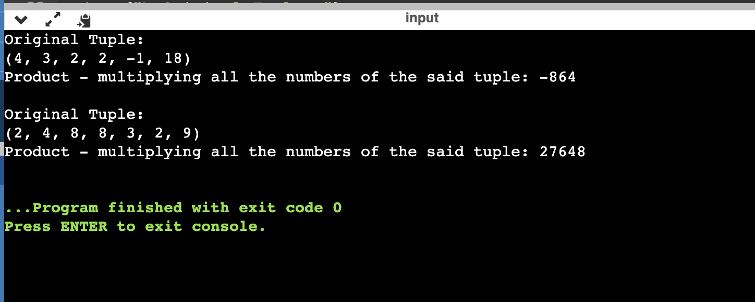

1. **Write a Python program to convert a tuple of string values to a tuple of integer values**

**Source Code:**

def tuple_int_str(tuple_str):

result = tuple((int(x[0]), int(x[1])) for x in tuple_str)

return result

tuple_str = (('333', '33'), ('1416', '55'))

print("Original tuple values:")

print(tuple_str)

print("\nNew tuple values:")

print(tuple_int_str(tuple_str))

**OUTPUT:**

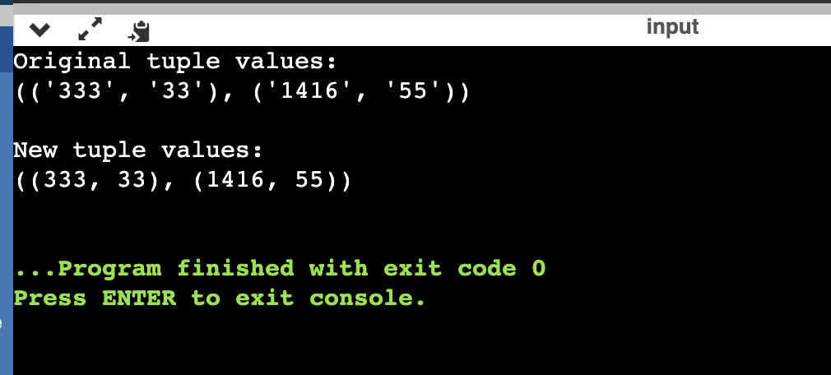

1. **Write a Python program check if a specified element presents in a tuple of tuples.**

**Source Code:**

def check_in_tuples(colors, c):

result = any(c in tu for tu in colors)

return result

colors = (

('Red', 'White', 'Blue'),

('Green', 'Pink', 'Purple'),

('Orange', 'Yellow', 'Lime'),

)

print("Original list:")

print(colors)

c1 = 'White'

print("\nCheck if",c1,"presenet in said tuple of tuples!")

print(check_in_tuples(colors, c1))

c1 = 'White'

print("\nCheck if",c1,"presenet in said tuple of tuples!")

print(check_in_tuples(colors, c1))

c1 = 'Olive'

print("\nCheck if",c1,"presenet in said tuple of tuples!")

print(check_in_tuples(colors, c1))

**OUTPUT:**

